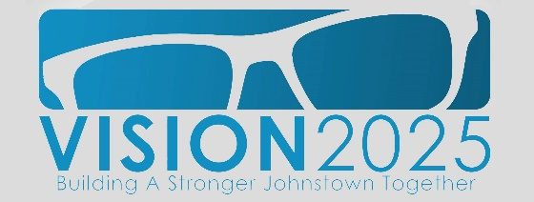

Capture Awards – April 2018

$5,000.00 – Central Park Square Capture Team

The Central Park Square Marketing Team will use this funding to bring a new logo to life, printing the design on banners and other materials, and displaying the new logo around Central Park. This award will also support lighting upgrades around the Square, creating better sight lines and upgrading security.

This project is sure to attract more shoppers and diners to Downtown Johnstown, and inspire pride in local residents.

$2,500.00 – Johnstown Nature Consortium

This award will fund a map of the city’s river and land trails. This map will help a consortium of Environmental Circle Capture Teams in efforts to rebrand Johnstown as a driver of ecotourism.

This project will help stakeholders visualize and promote the economic and health stimulus the outdoor sector provides this community.

$1,000 – Overdose Prevention Team

The Overdose Prevention Team – or O.P.T. Out – will use this award to create a Healing Garden at Sandyvale Memorial Gardens and Conservancy. This garden will honor people who have lost their battle with drug addiction, raise awareness, and provide a place of healing for addicts and their families.

Along with the Healing Garden, O.P.T Out is undertaking a marketing campaign to promote resources available to addicts, and information for the community on destigmatizing addiction.

$1,000.00 – Gatherings on Gazebo

Gatherings on Gazebo creates a forum where individuals can meet for formal or informal discussions, with the goal of gathering, engaging, and enlightening visitors. This will also be a place for art exhibits, demonstrations, meetings, and other social engagement.

This space will strengthen our community by bringing together a cross-section of socio-economic groups, so we can all learn more about each other develop bonds. It will also add to the vibrancy of Downtown Johnstown by renovating and inhabiting a space on the Square, and partnering with neighbors for events and activities to attract patrons.

$1,000.00 – Antiques, Crafts & Collectibles

The Antiques, Crafts, & Collectibles Capture Team will put this award toward a monthly fair, giving local vendors a place to sell antiques, crafts, and collectibles on three Saturdays this summer. This will bring patrons downtown on weekends, generally a quiet time for the business district. It also showcases Downtown as a destination for businesses and restores specialty retail and entertainment to the district.

$500.00 – Rivers Capture Team

The Rivers Capture Team will use this award to create a ramp to the Stonycreek River running through the Moxham and Ferndale neighborhoods, making the river more accessible to locals and tourists.

$500.00 – Friends of Cambria City

This award will fund beautification in Johnstown’s historic, cultural center. The Friends of Cambria City will install benches, banners, and dog stations along Chestnut Street, and paint crosswalks in ethnic themes that reflect the city’s heritage.

